**Ethylene and Propylene: Organic Chemicals**

JRC: Best Available Techniques (BAT) Reference Document for the Production of Large Volume Organic Chemicals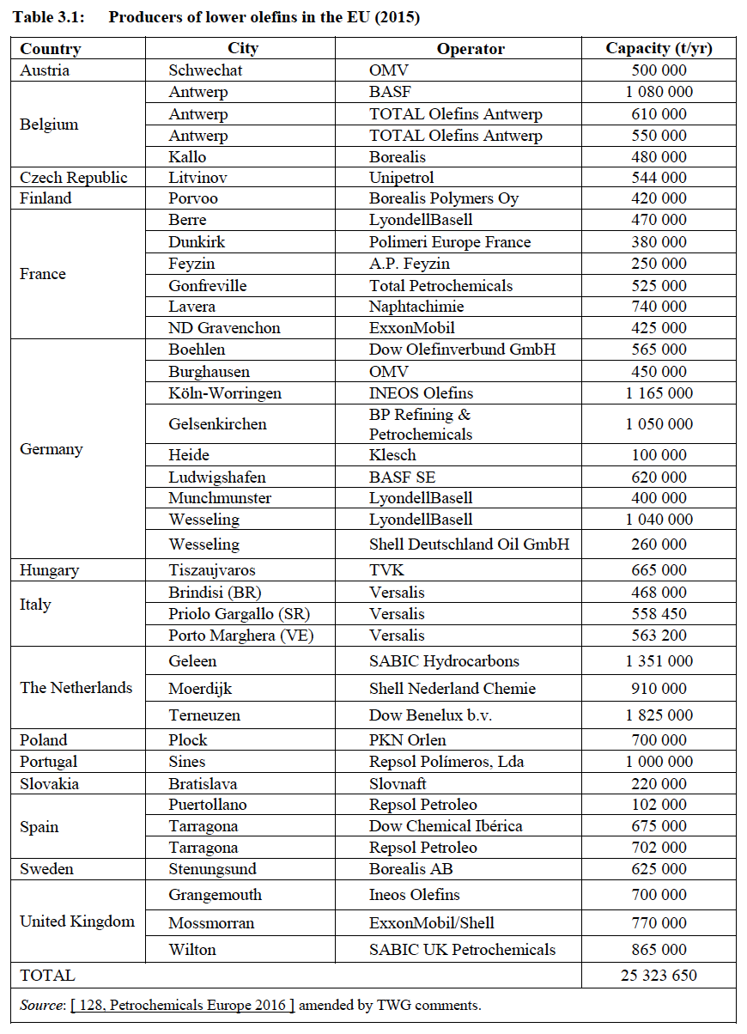

Divided half for ethylene and half for propylene

**Aromatic: Toluene, Benzene, Orthoxylene and Paraxylene**

<https://www.icis.com/explore/resources/news/2015/04/06/9873229/chemical-profile-europe-toluene/>

<https://www.icis.com/explore/resources/news/2012/10/15/9603331/europe-chemical-profile-benzene/>

<https://www.icis.com/explore/resources/news/2012/05/07/9556557/europe-chemical-profile-orthoxylene/>

<https://www.icis.com/explore/resources/news/2011/07/04/9474487/european-chemical-profile-paraxylene/>

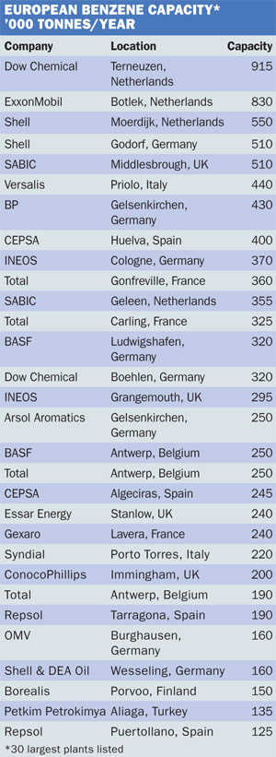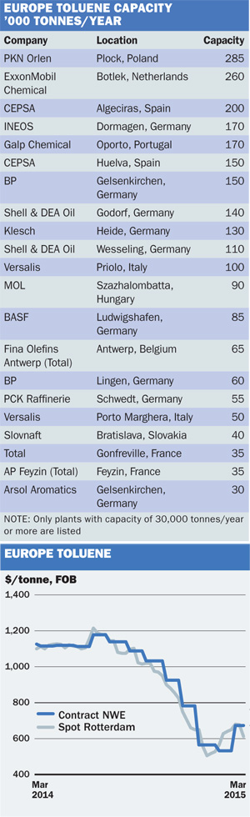

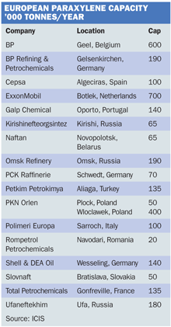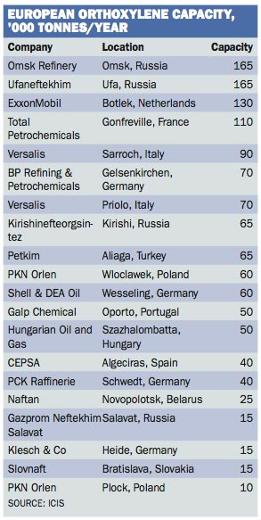

**Methanol**

<https://www.icis.com/explore/resources/news/2012/06/25/9571858/europe-chemical-profile-methanol/>

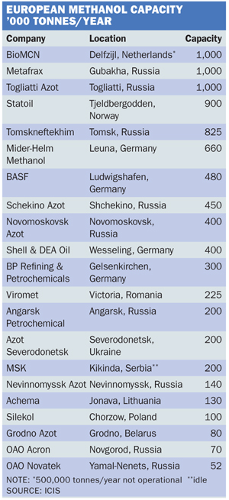

**Aluminum**

<https://www.european-aluminium.eu/activity-report-2020-2021/market-overview/>

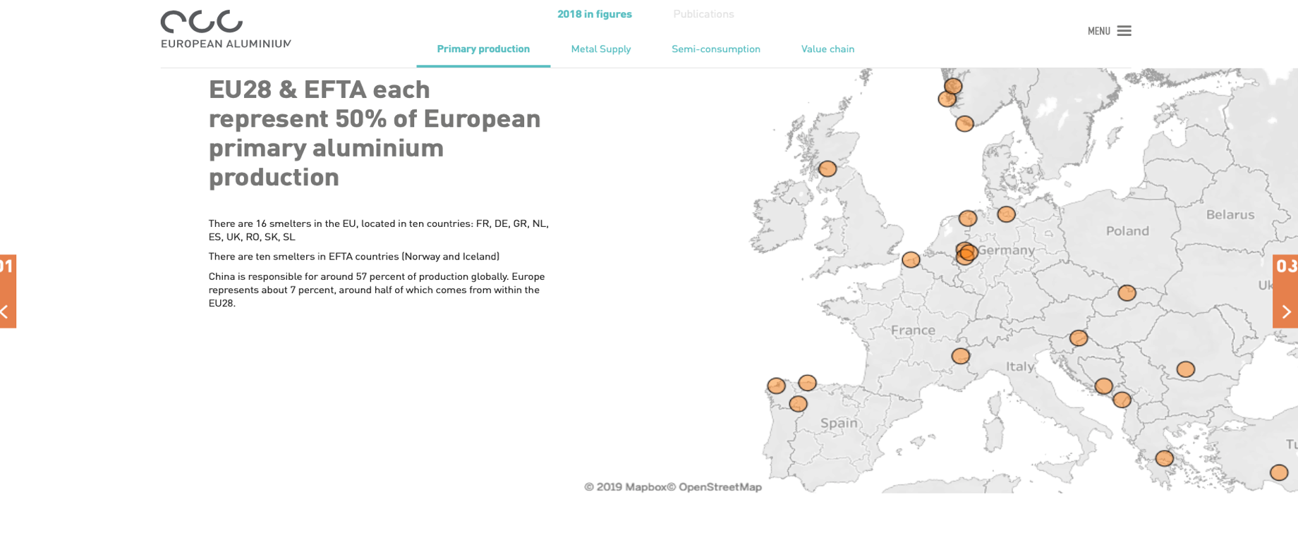There are a total of 15 smelters in the EU, of which two were idled in 2019. The remaining 13 are located in nine countries: France, Germany, Greece, The Netherlands, Spain, Romania, Slovakia, Slovenia and Sweden. There are 10 smelters in EFTA countries (Norway and Iceland) and one smelter in the United Kingdom.

<https://face-aluminium.com/wp-content/uploads/2019/06/2019-LUISS-Study.pdf> (primary aluminum: from page 40 on)

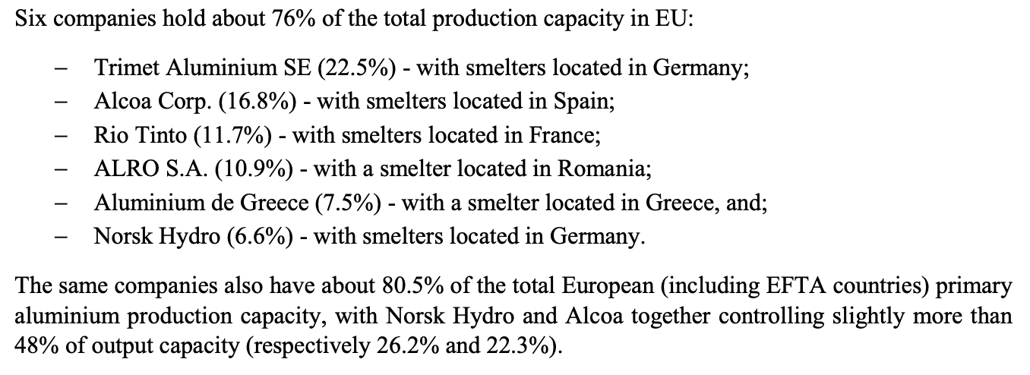

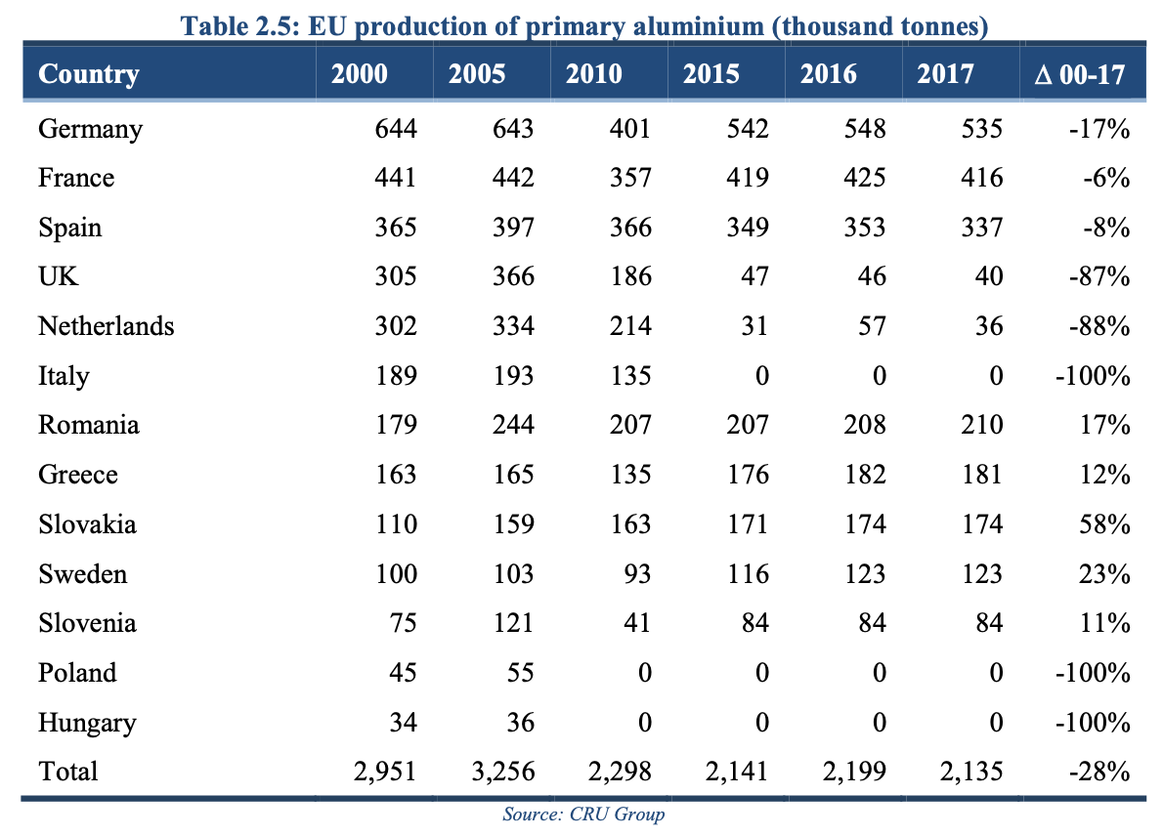

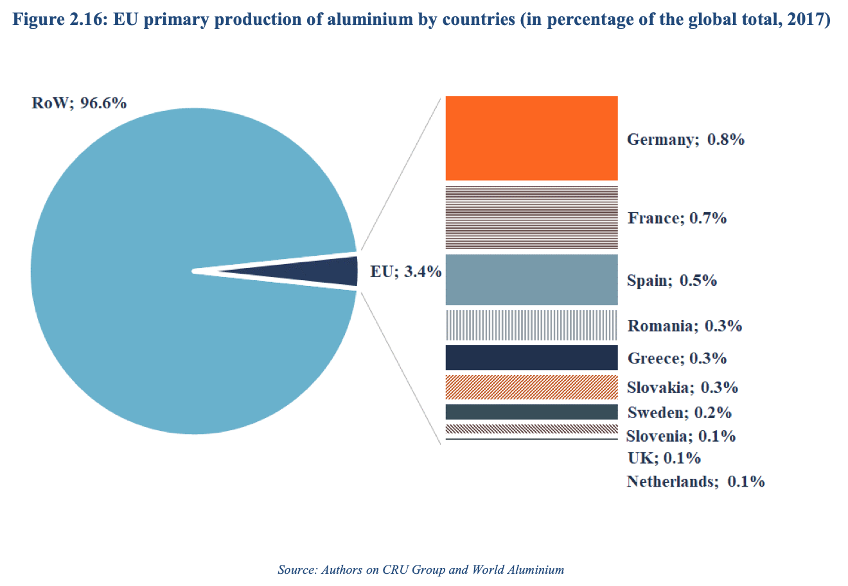

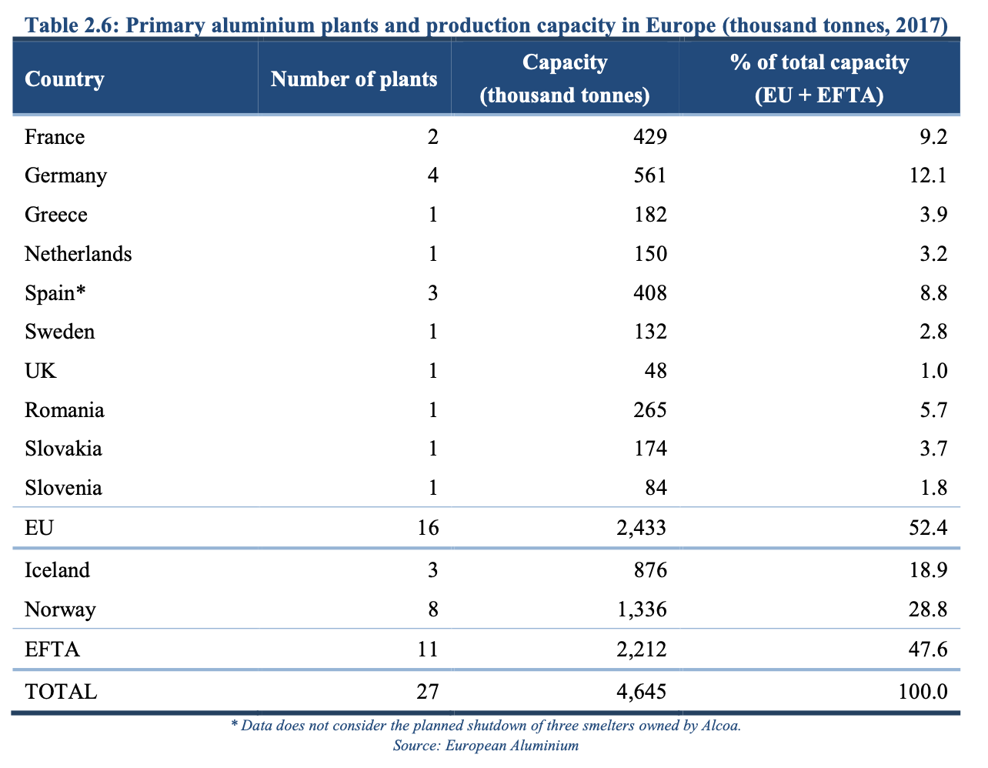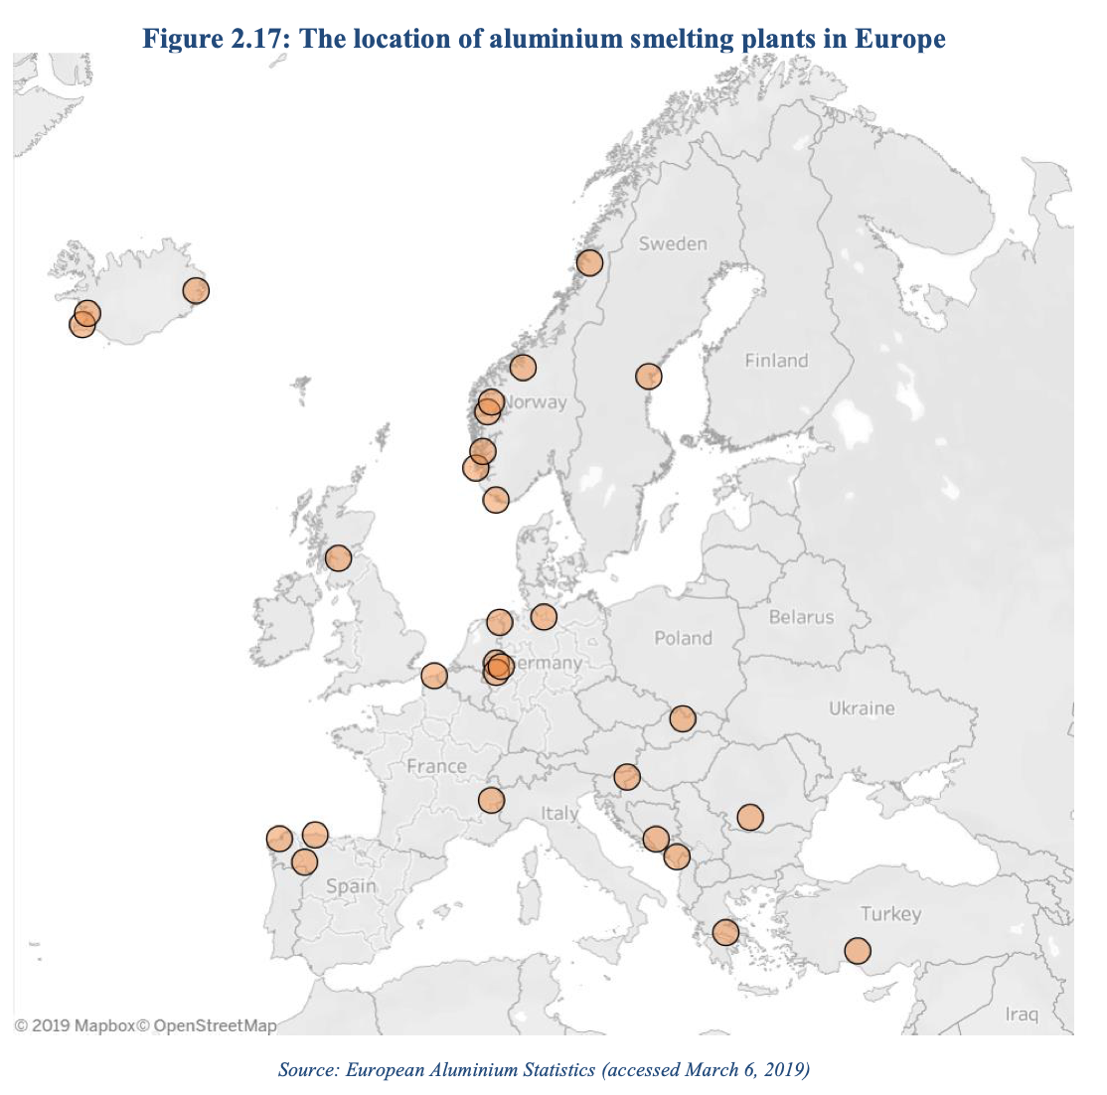

<https://www.world-aluminium.org/statistics/primary-aluminium-production/>

* **West Europe:** Austria (1/1973-10/1992), France, Germany, Greece, Iceland, Italy, Netherlands* (1/2014-Present), Norway, Spain, Sweden, Switzerland (1/1973-4/2006), United Kingdom* (1/2017-Present)
* **East & Central Europe:** Bosnia and Herzegovina* (1/1981-Present), Croatia*, German Democratic Republic* (1/1973-8/1990), Hungary* (1/1973-6/1991), Hungary (7/1991-1/2006), Hungary (7/1991-1/2006), Montenegro (6/2006-Present), Poland*, Romania*, Russian Federation* (1/1973-8/1994), Russian Federation (9/1994-Present), Serbia and Montenegro* (1/1973-12/1996), Serbia and Montenegro (1/1997-5/2006), Slovakia* (1/1975-12/1995), Slovakia (1/1996-Present), Slovenia* (1/1973-12/1995), Slovenia (1/1996-Present), Ukraine* (1/1973-12/1995), Ukraine (1/1996-Present)

Final report European Commission: CRM_2020_Critical_Factsheets (pages 59 and 60)

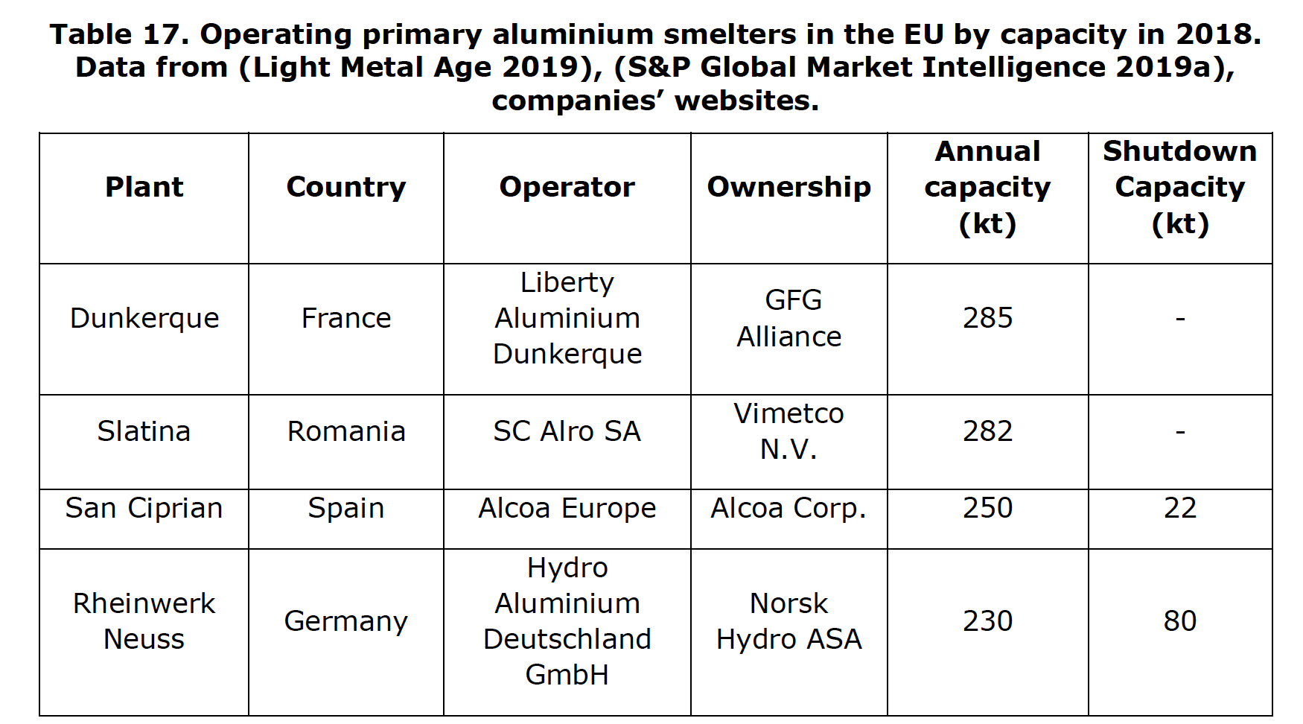

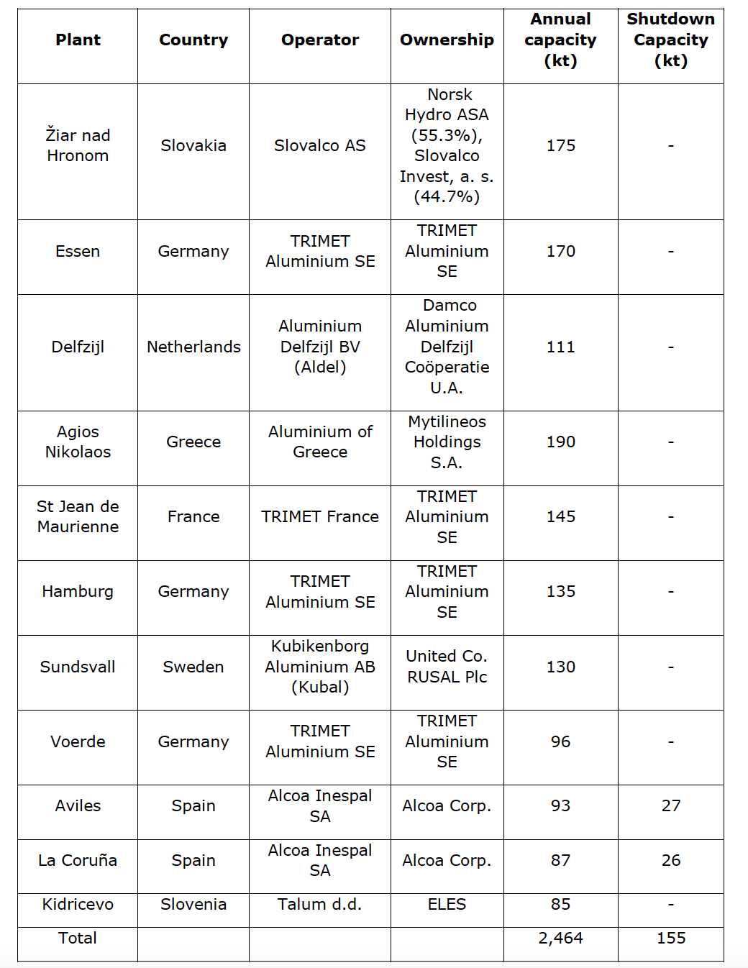

Important spots in the map but not in the table:

* UK:
  + Fort William: Capacity 42000, Rio Tinto Alcan - Lochaber Smelter
* Iceland:
  + Reyðarfjörður: 346,000, Alcoa Fjarðaál
  + Grundartangi, near Akranes: 312,000, Nordic Aluminum Co (Norðurál), subsidiary of Century Aluminum
  + Straumsvik, near Hafnarjordur: 205,000, Rio Tinto
  + Helguvíkurvegur, near Keflavík: 250,000, Nordic Aluminum Co (Norðurál), subsidiary of Century Aluminum
* Norway:
  + Sunndalsøra: 400,000, Sunndal Primary Production (Haas)
  + Årdal: 233,000, Årdal Primary Production (Haas)
  + Mosjøen: 221,500, Alcoa Norway - Mosjøen Works
  + Karmøy: 190,000, Karmøy Primary Production (Haas)
  + Husnes: 185,000, Hydro Husnes (Norsk Hydro)
  + Lista: 127,500, Alcoa Norway - Lista Works
  + Høyanger: 60,000, Høyanger Primary Production (Haas)
* Montenegro:
  + Podgorica: 120,000, DP Kombinat Aluminijuma Podgorica (KAP)

**Chlorin**

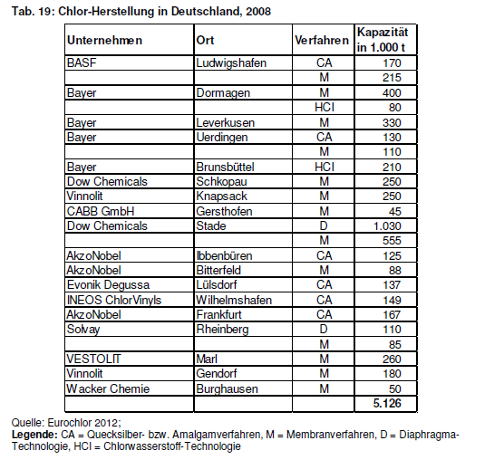

<https://www.eurochlor.org/wp-content/uploads/2019/04/2013-annualreview-final.pdf>

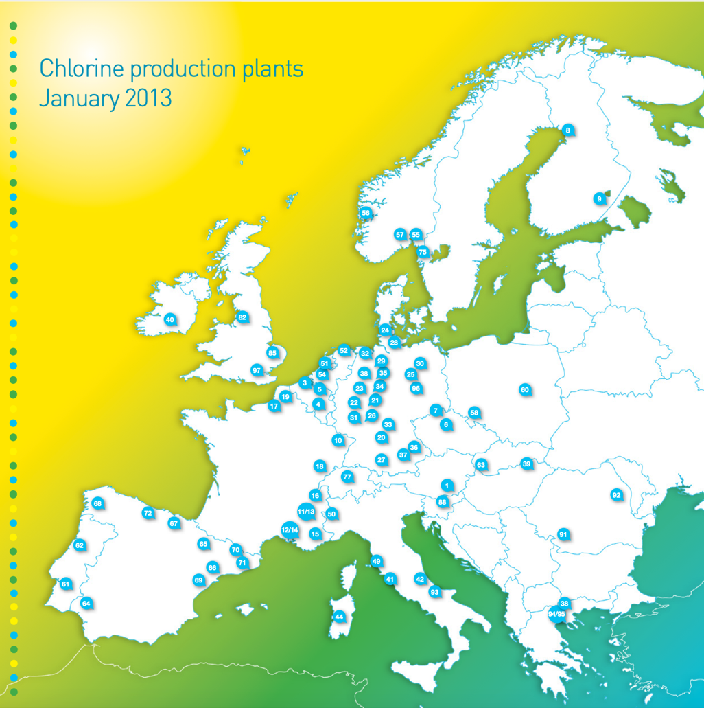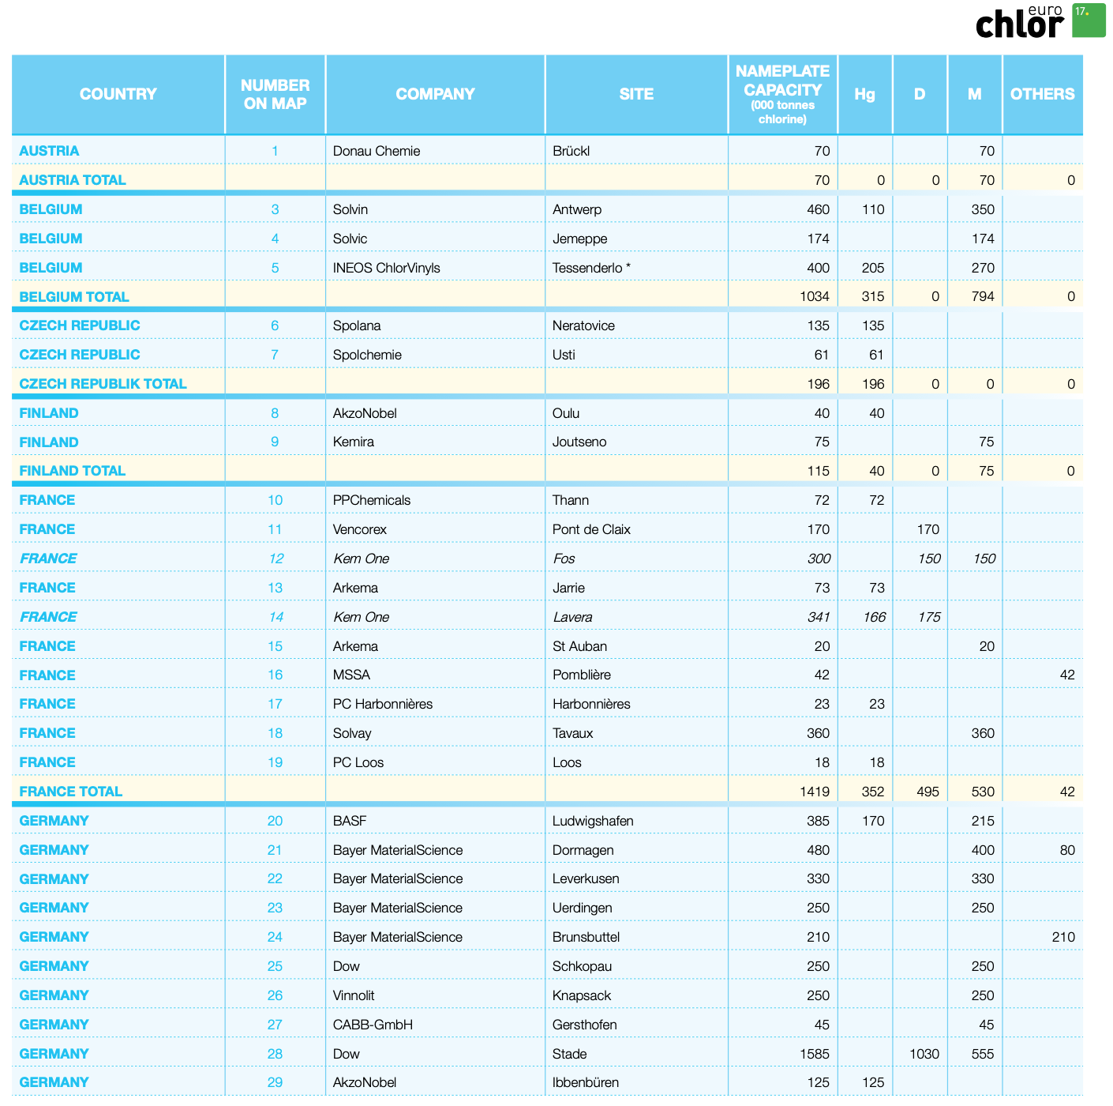

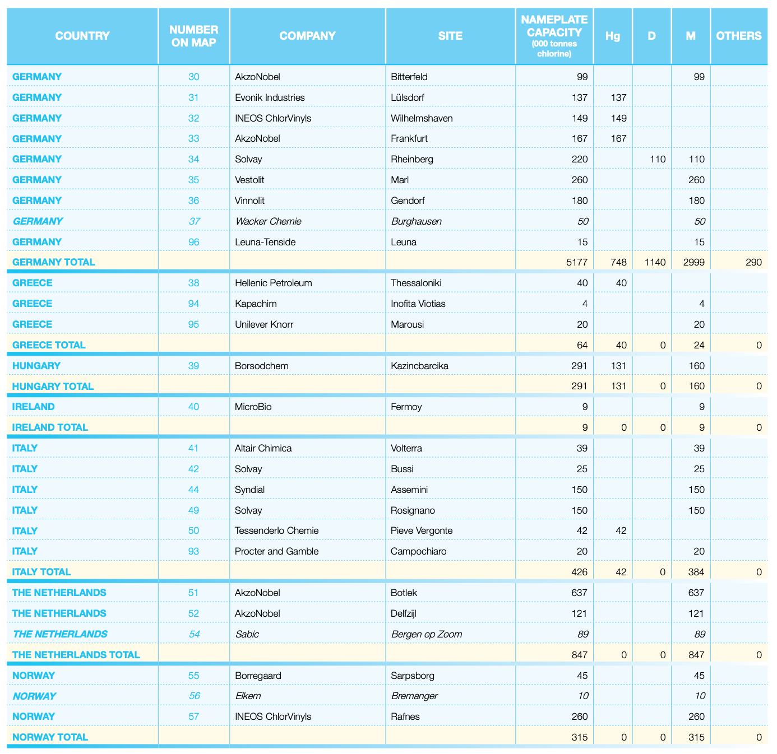

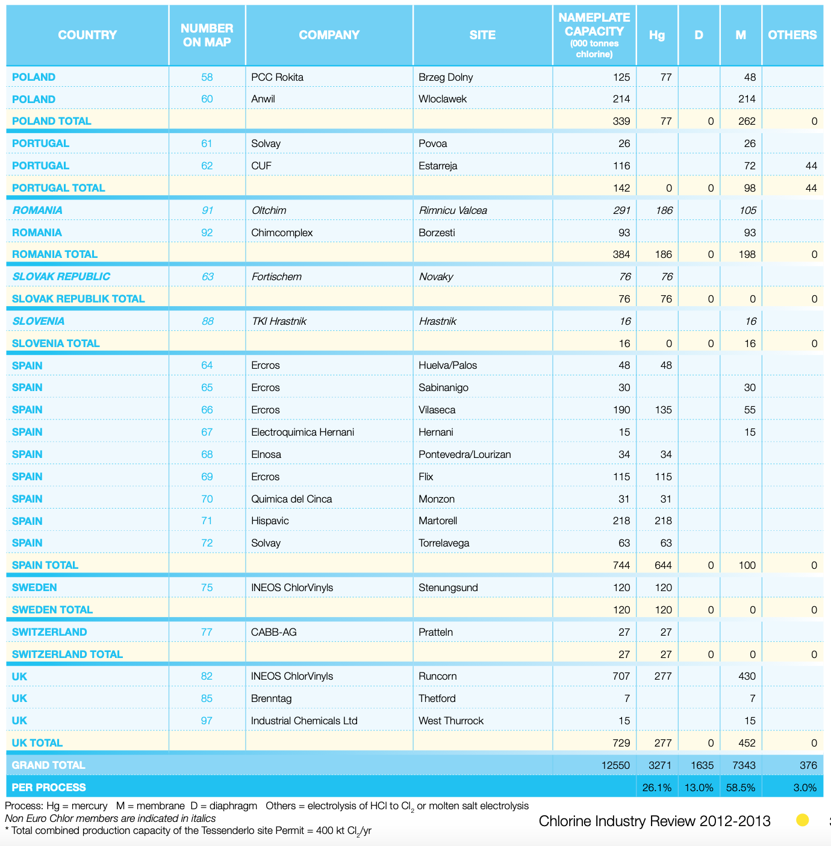

**Paper**

<https://eippcb.jrc.ec.europa.eu/sites/default/files/2019-11/PP_revised_BREF_2015.pdf>

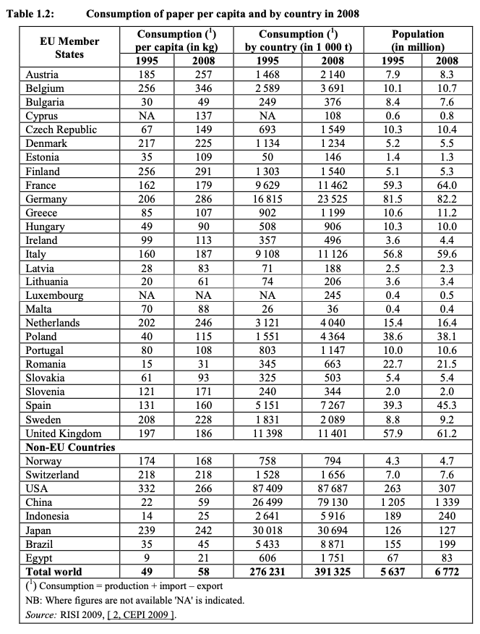

<https://www.cepi.org/wp-content/uploads/2020/07/Final-Key-Statistics-2019.pdf>

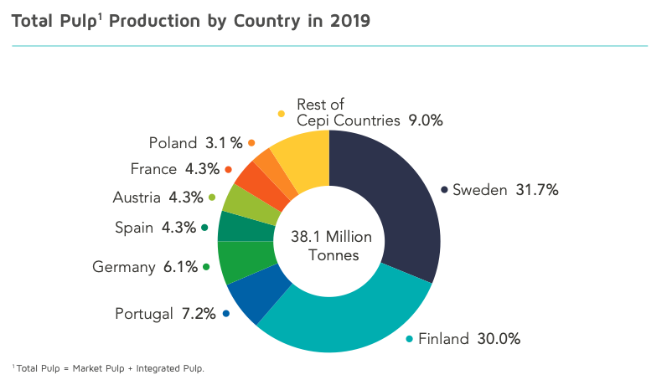

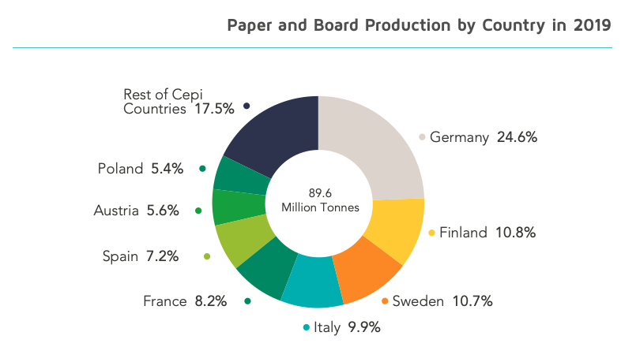

🡪 equally distributed?

<https://ec.europa.eu/eurostat/statistics-explained/index.php?title=File:Wood_and_wood_products;_pulp,_paper_and_paper_products_(NACE_Subsection_DD_and_Division_21)_Persons_employed_in_the_manufacture_of_wood_and_paper_(NACE_Subsection_DD_and_Division_21)_MAP.PNG>

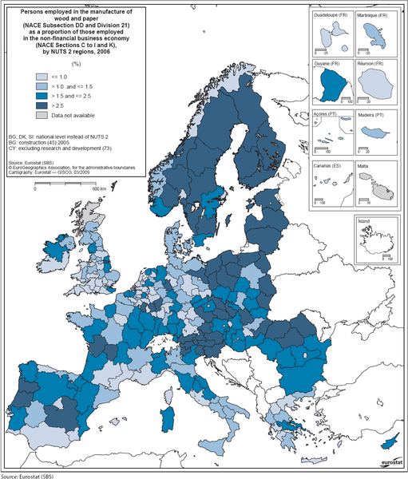

<https://publications.lib.chalmers.se/records/fulltext/185715/local_185715.pdf>

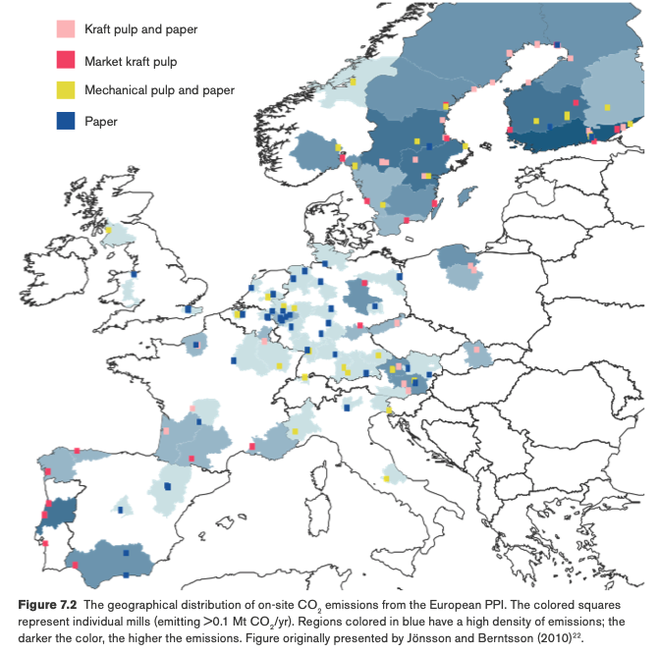

**Steel**

<https://www.eurofer.eu/assets/Uploads/Map-20191113_Eurofer_SteelIndustry_Rev3-has-stainless.pdf>

Steel is Blast Furnace & Oxygen (Finished Steel Capacity) + Electric Arc

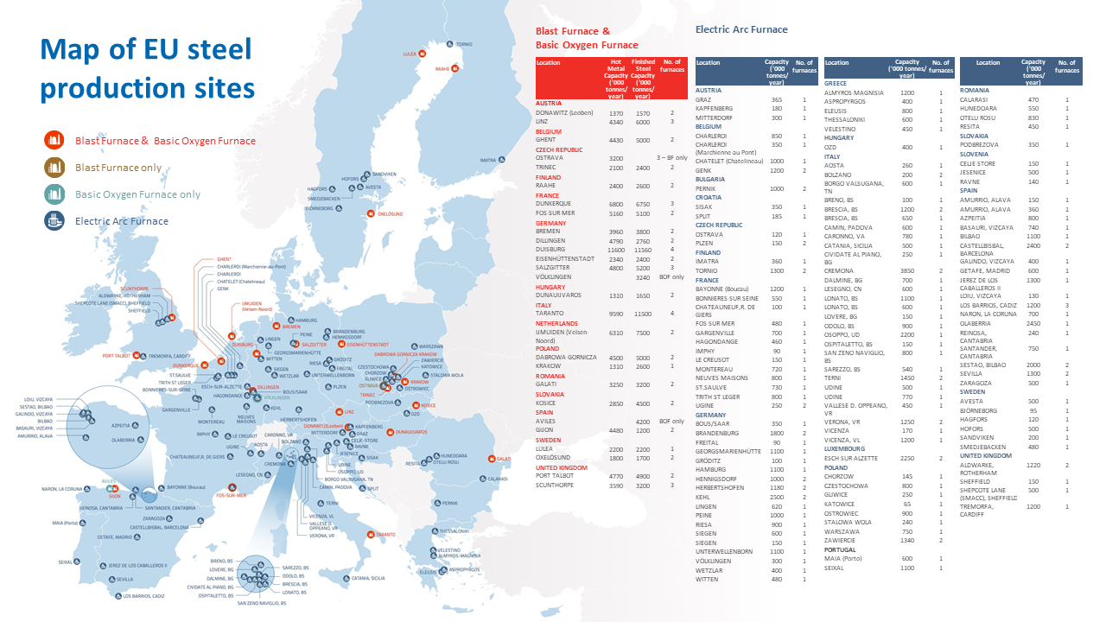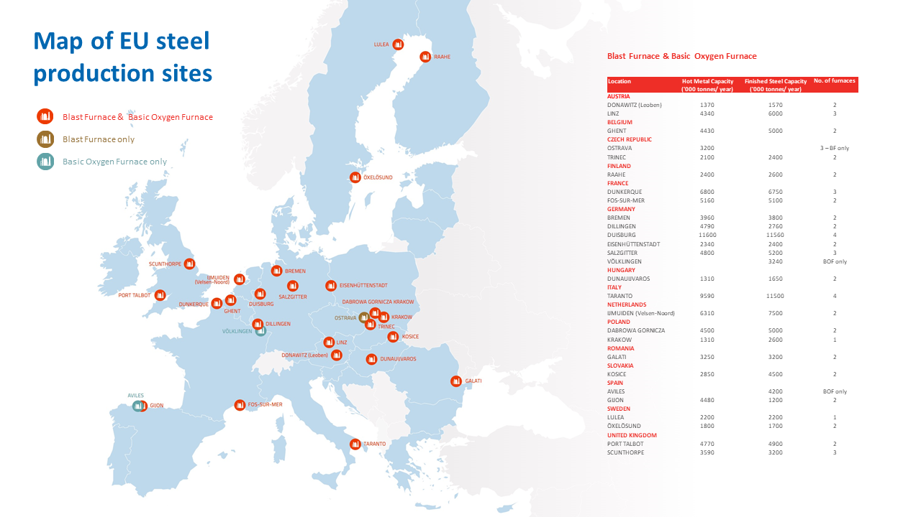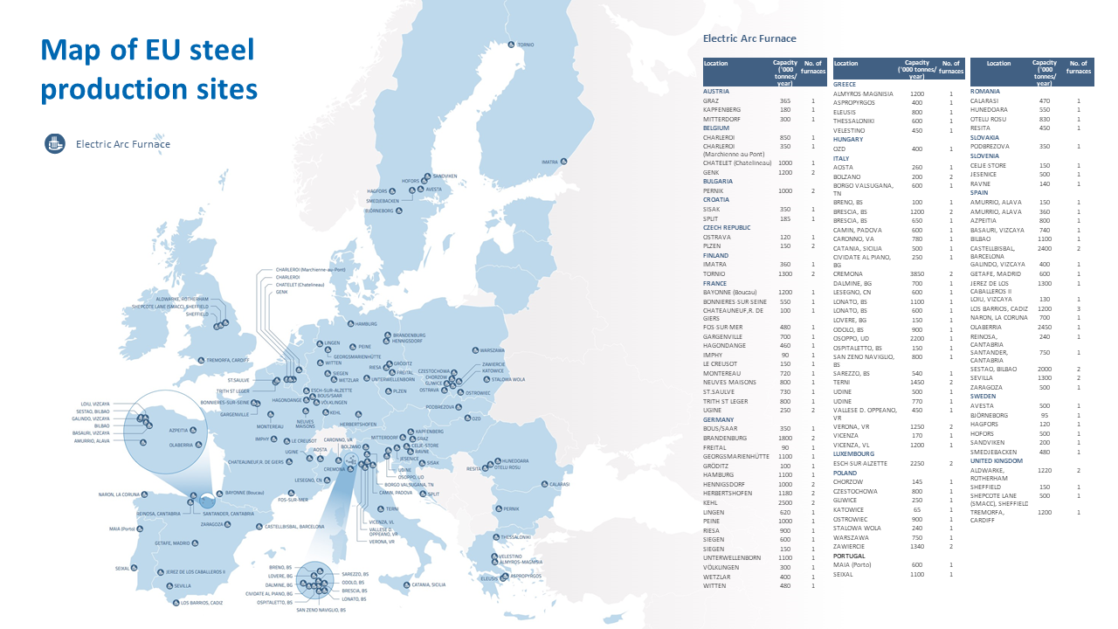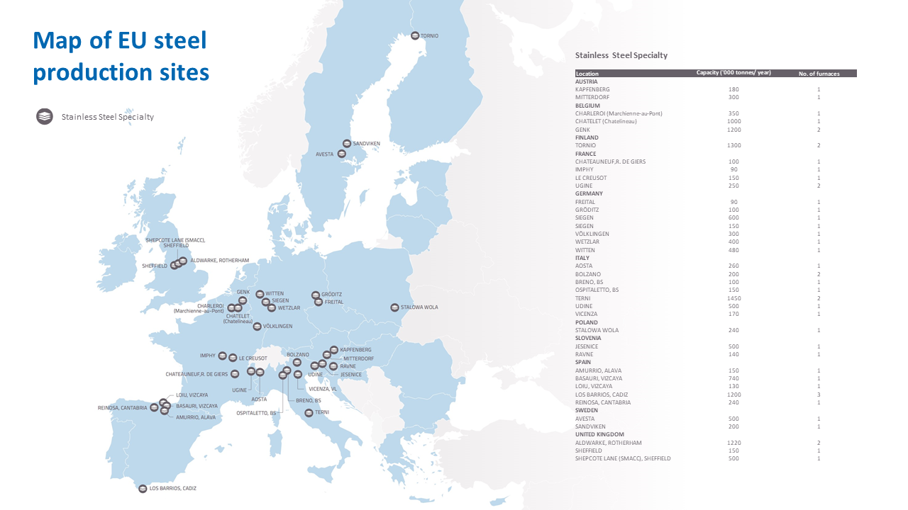

**Glass**

<https://www.glassallianceeurope.eu/en/main-glass-sectors>

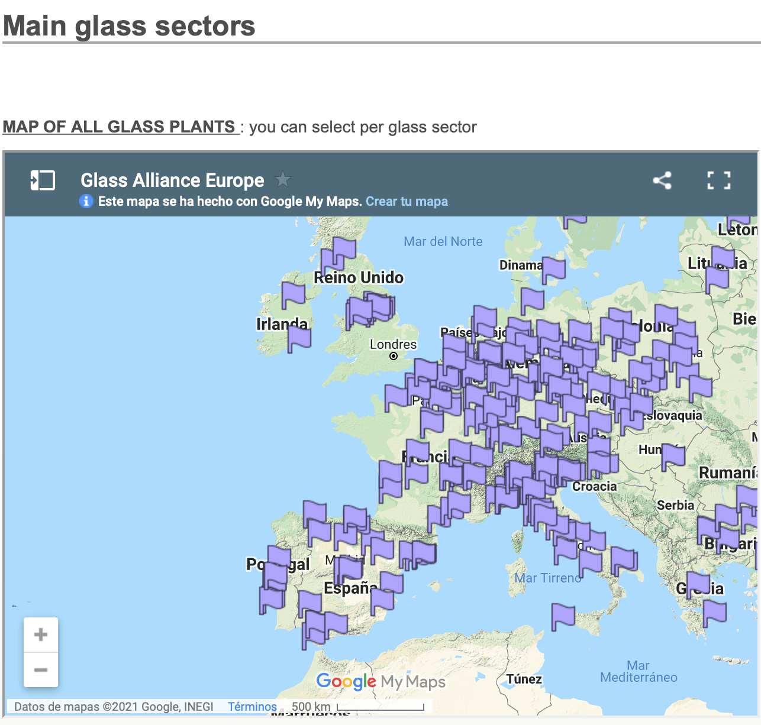

Map link: "<https://www.google.com/maps/d/u/2/embed?mid=z1zz1byO2tRw.kqh2OYwbS6J0>"

**Ammonia**

ceps-entr2008006lot4-ammonia_en.pdf Page 8

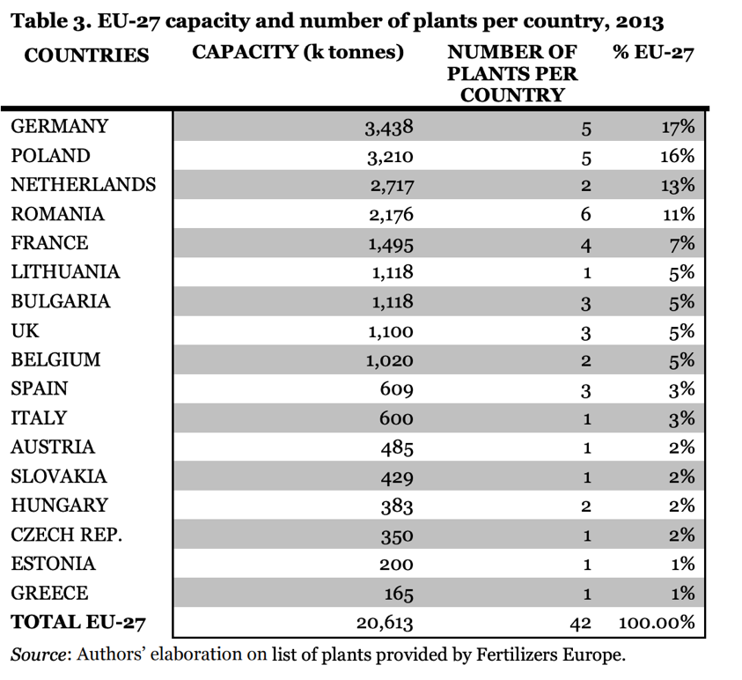

<https://www.icis.com/explore/resources/news/2008/10/27/9166031/chemical-profile-ammonia/>

